Name: _______________________________________________ Period: ____ Date: ________________

Soil Layers

Part One: Use the word bank to label the empty boxes along the right side of the image below.
Word Bank

parent material topsoil humus surface litter subsoil

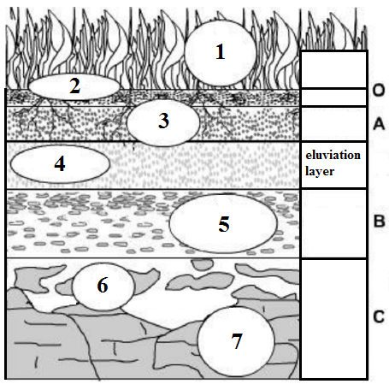
Part Two: Write the number from the image above next to the correct description.
_____ Animal and plant waste accumulates in this layer. Animals and plants use this nutrient-rich soil to live and grow.
_____ This layer has little organic material, but is has many minerals and nutrients.

_____ Animals and plants decompose and live in this layer. Here you will find lots of roots and bacteria.
_____ This hard layer has no organic material. It was formed before the rest of the layers and will not change until it is exposed to erosion or weather.
_____ This is the layer that has all the nutrients that have been washed down from the topsoil.

_____ On the surface of the soil, fresh organic material is collected.

_____ This layer is on top of solid rock. It is usually made of sedimentary rock, which has formed by compacting loose sediments together.

